

FCIT Clubs

Group #6

| Name | students ID |
| --- | --- |
| Jana Kurdi | 1906167 |
| Jomana Almagrabi | 1910769 |
| Razan Alshaikh | 1906813 |
| Renad Ghaleb | 1908460 |

Section AAE

15/11/2023

**Table of Contents**

***Abstract 3***

***Introduction 3***

***details of tasks 3***

***screenshots, 3***

***snippets of code 3***

***conclusion. 3***

# **Abstract**

# The aim of this project is to create a website that facilitates students' access to the clubs and extracurricular activities offered by faculty of computing and information technology (FCIT) college. Students will be able to use keywords to search for clubs, courses, and events on the website. Additionally, students will have access to comprehensive details on every club, course, and activity, such as venues and sponsor contact details. Students will also be able to sign up directly through the website for clubs and activities.

# **Introduction**

# Students in college are generally preoccupied with their assignments and other responsibilities. Because of this, it could be challenging for them to find the time to discover and engage in the extracurricular activities that are offered. so we thought to provide students with an online resource for locating and enrolling in clubs and activities. The website will be made with flexibility of use and navigation in mind. Students will discover more about the activities they are interested in and be able to locate them quickly and efficiently.

# **Details of tasks**

| **Student** | **Task** |
| --- | --- |
| **Jana** | **Clubs registration form page - CSS stylesheets- JavaScript Events(focus- blur-onselect-onchange -confirm before submit and clear) - delete from database-report** |
| **Jomana** | **Home page include Script - Signup page-create users table-validate the user’s email structure and the password strength-Signup Backend page -Update from database-CSS stylesheets-report** |
| **Razan** | **Clubs page,contact page, create database, create request table, validate data before insert to database, store request to database, retrieve data from database request table.** |
| **Renad** | **Home page footer and header- login page-forget password-CSS stylesheets-new_Password-password_Changed-successfully-send_pass-reset-backend for reset password** |

# **Screenshots**

The home page

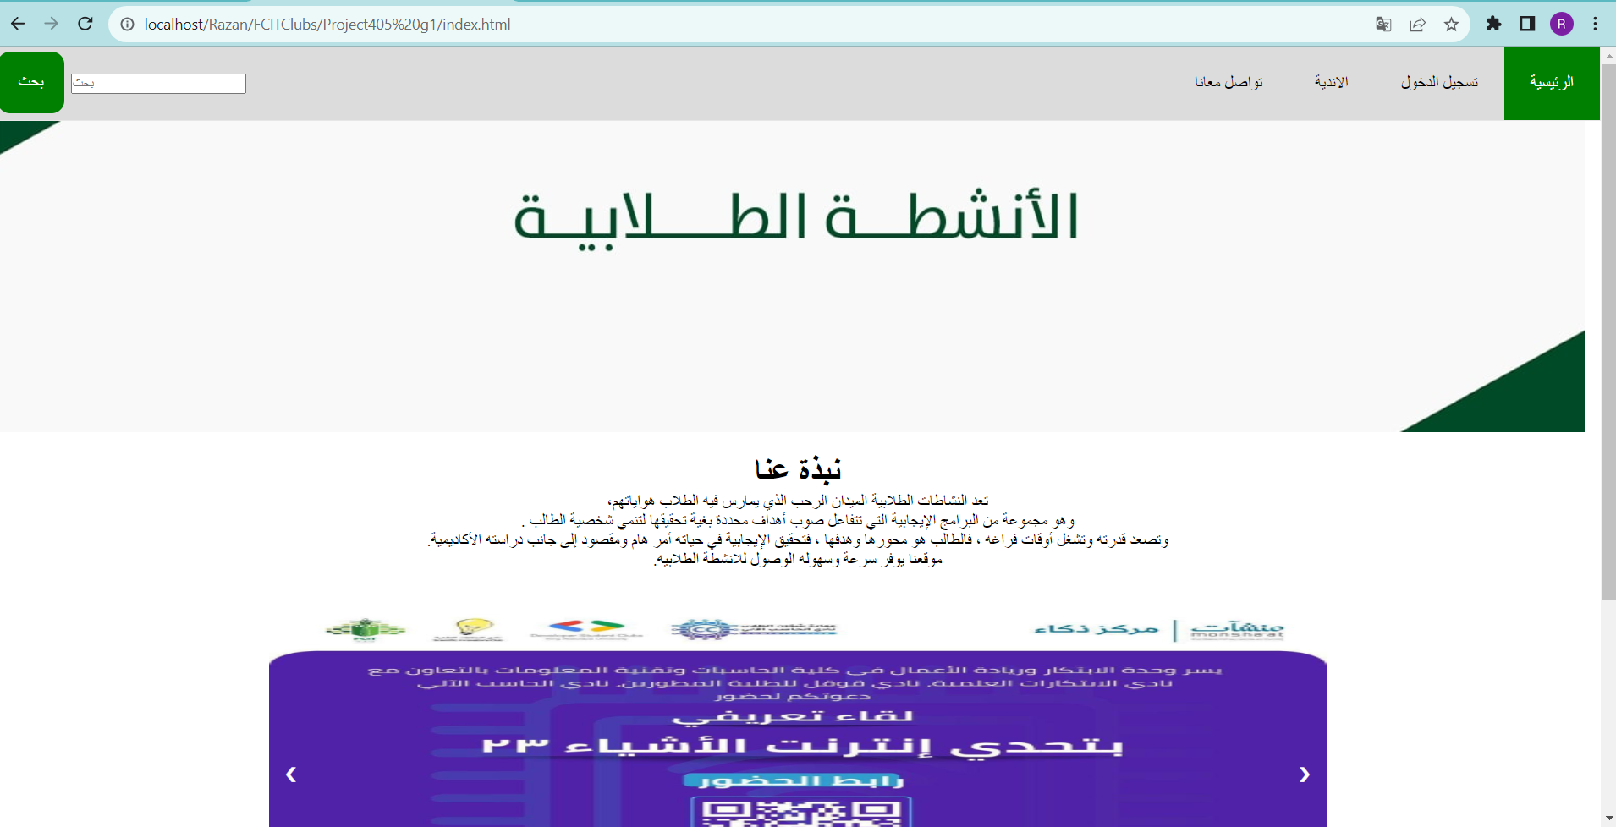

the clubs page

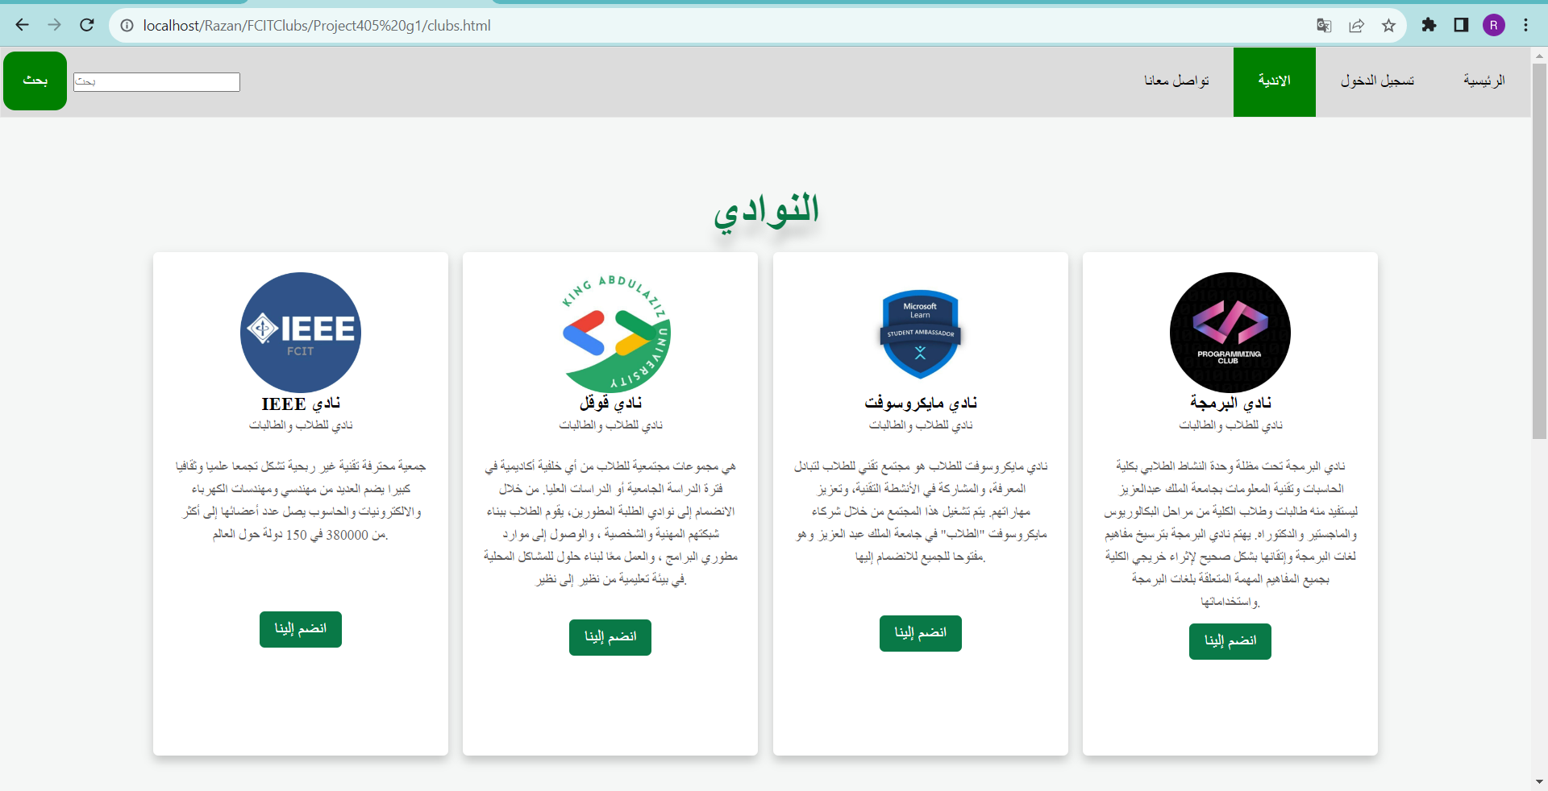

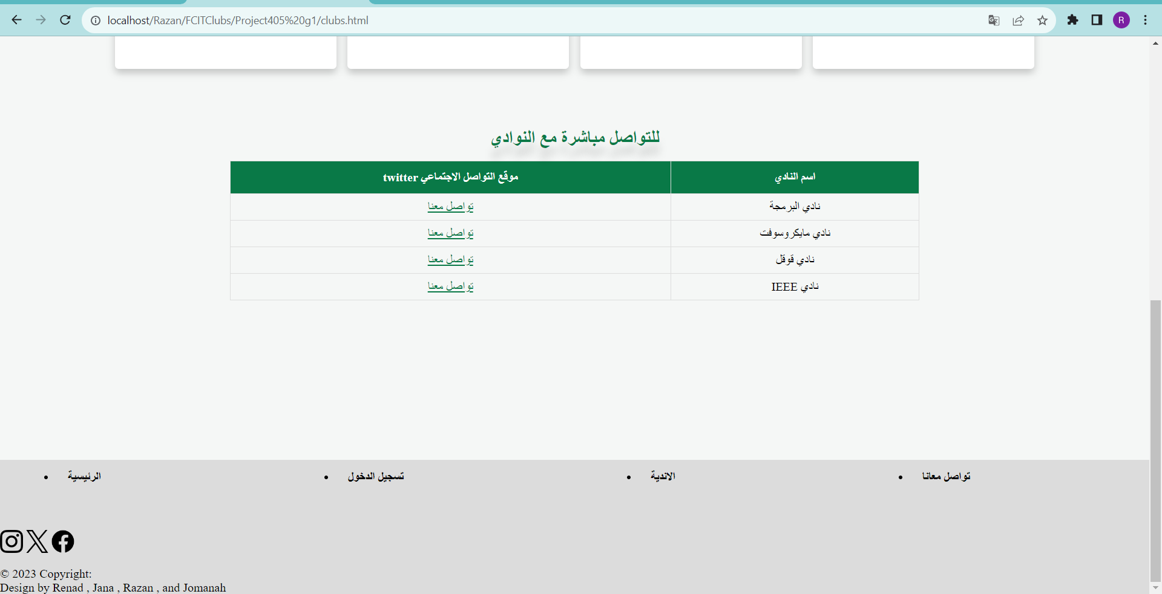

the form to join clubs

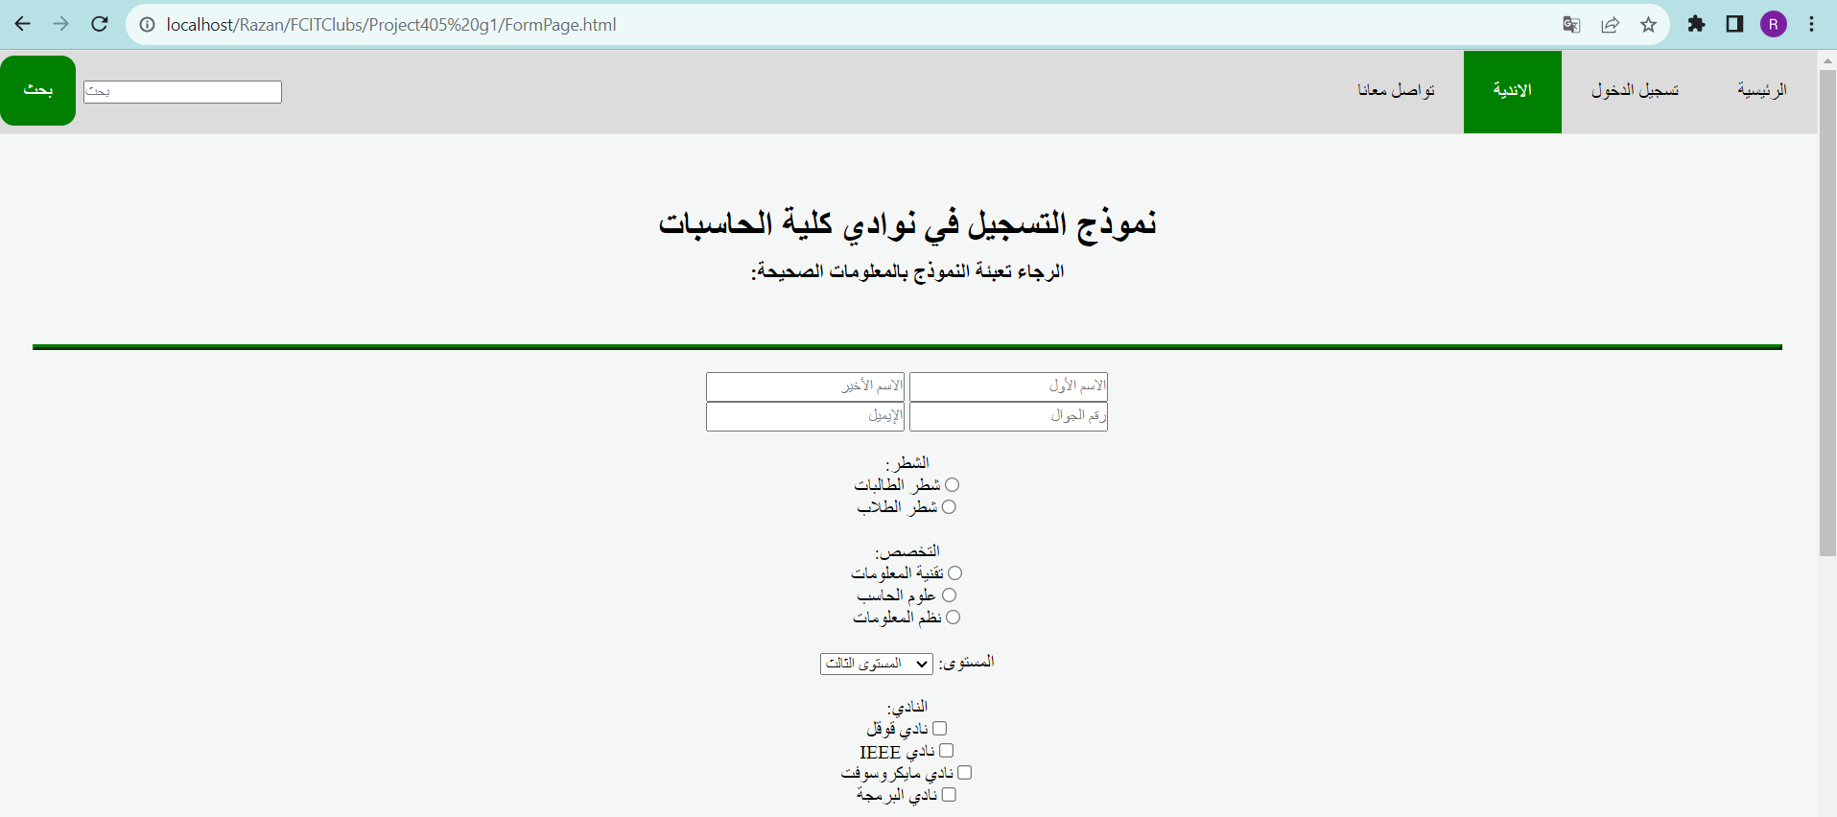



send a request to join clubs & store it in database

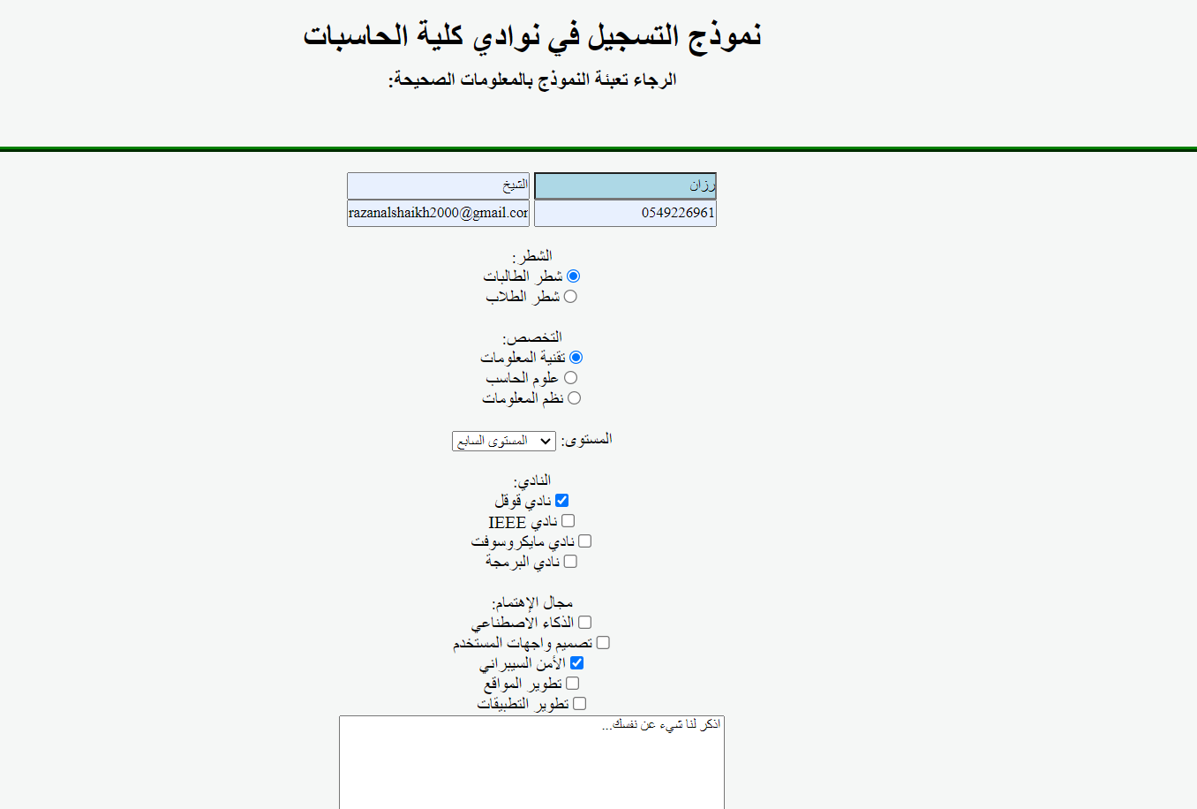

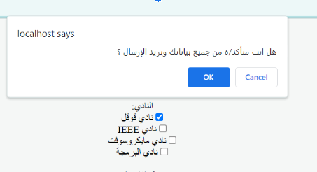

Retrieve the data from database and allow user to delete the request

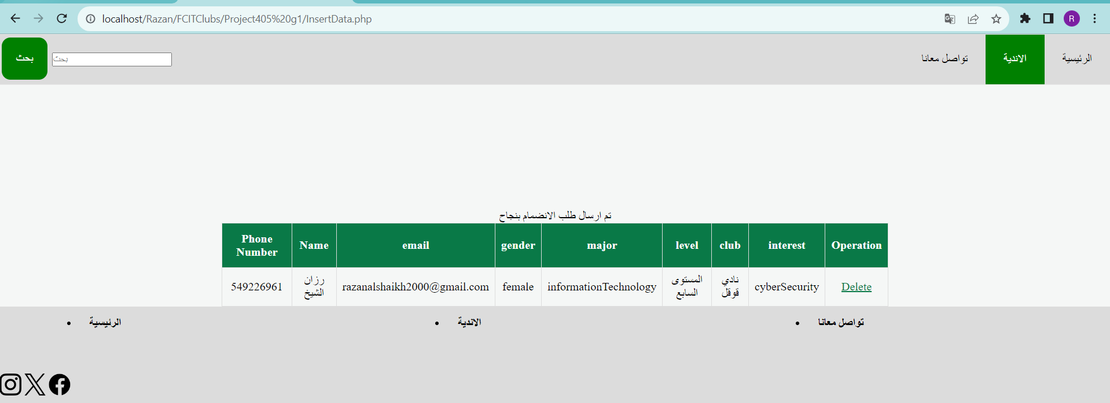

The request table in the database before deleting the request

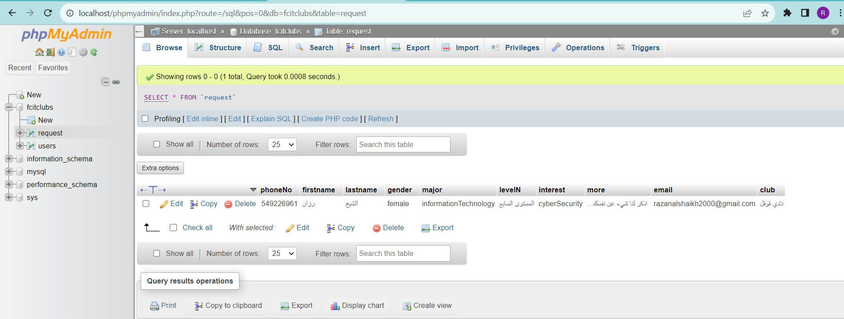

if the user press delete then it will be deleted from database



The database

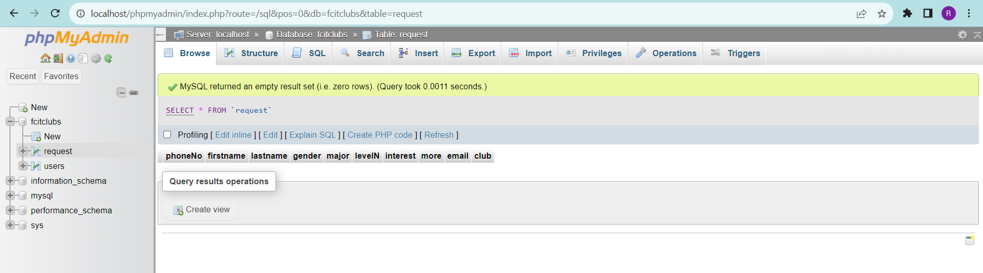

the contact us page

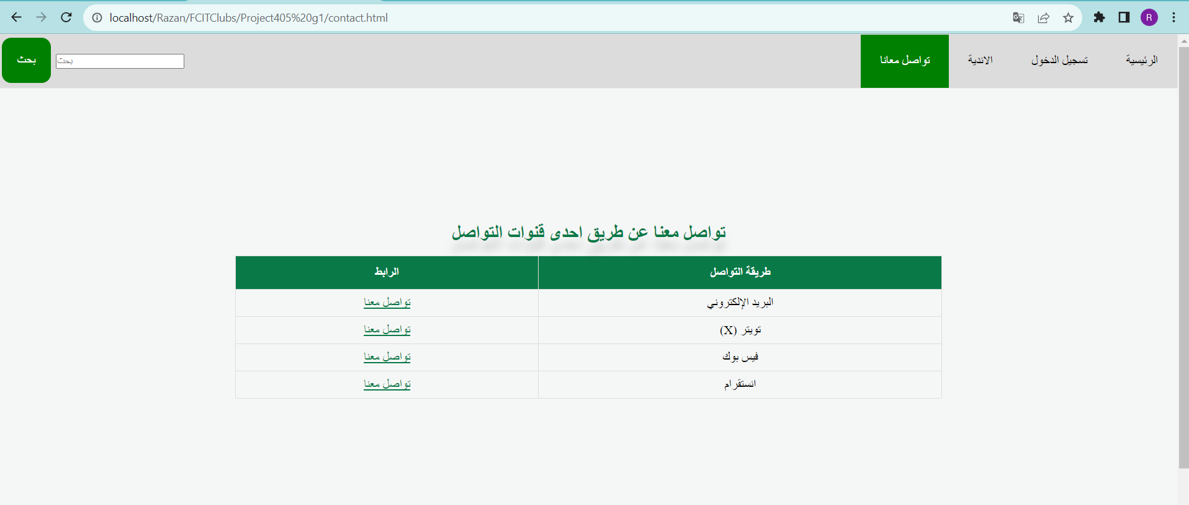

if user choose the email system will open the mail program with email address of the website customer service



the login page

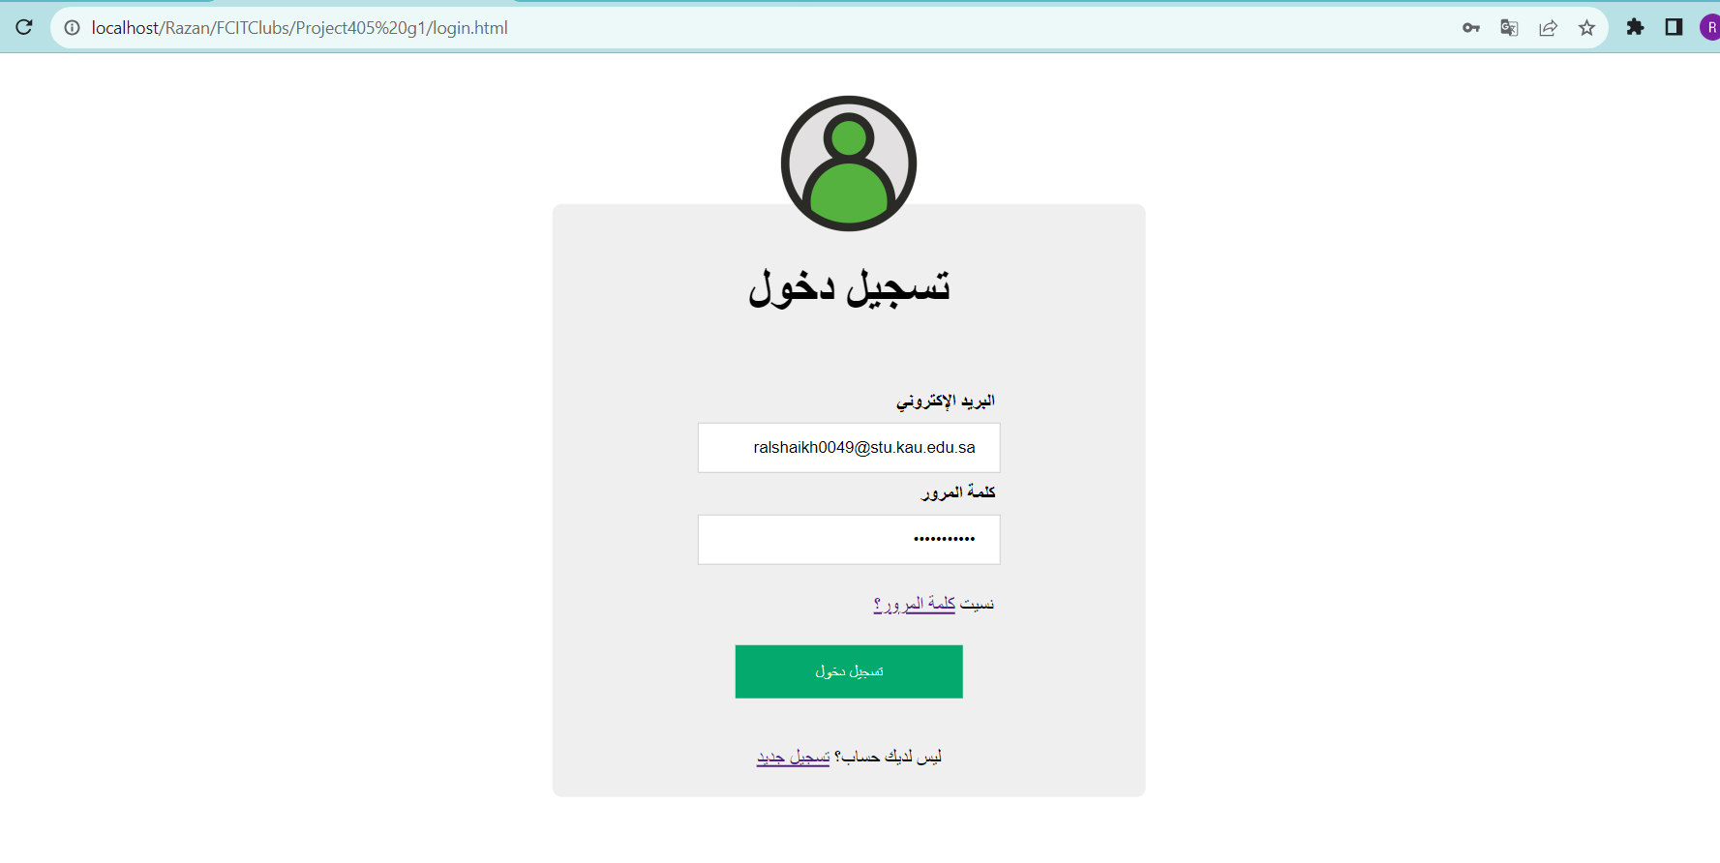

The user will see the home page if he has an account



if the user forgets the password he/she will enter their email address



then the user can enter new password

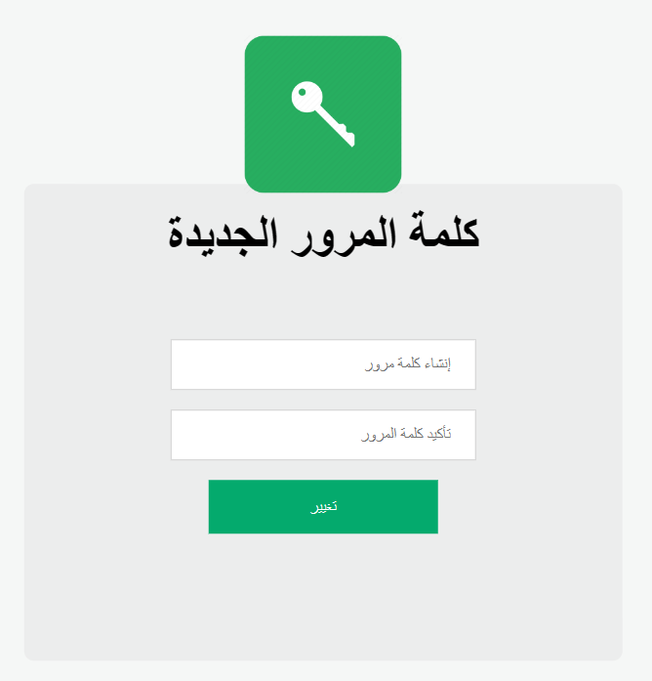

if password it is not match then

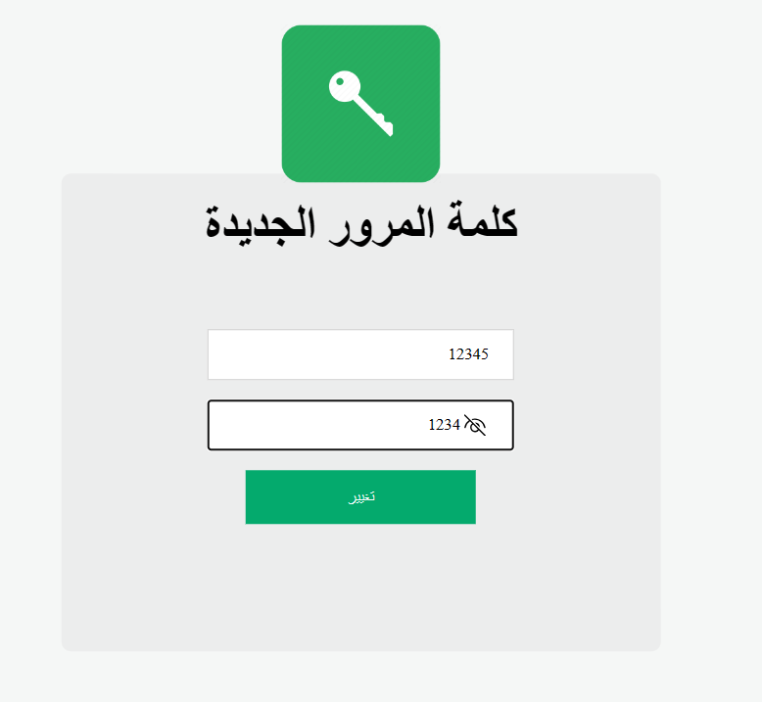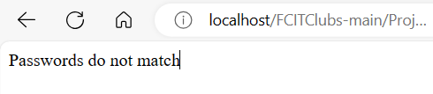

successfully page



The user will be sent to the account creation page if he does not already have one.

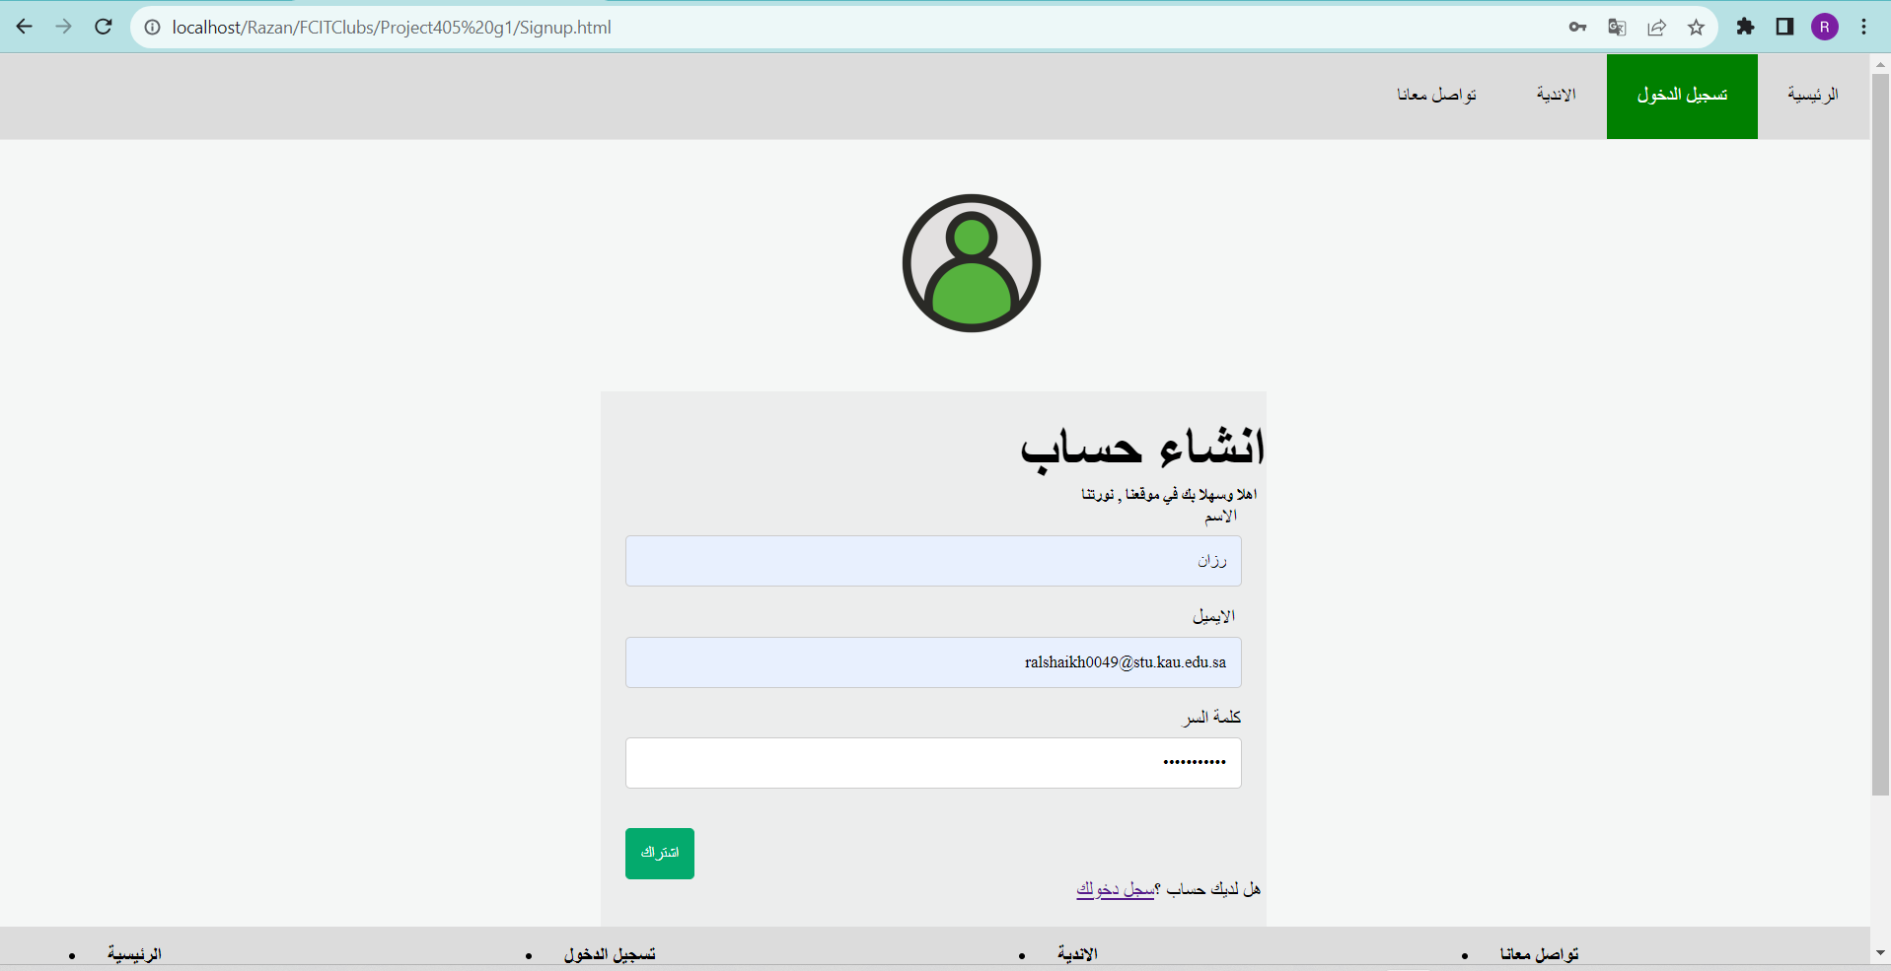

the user account information will be store in Database users table

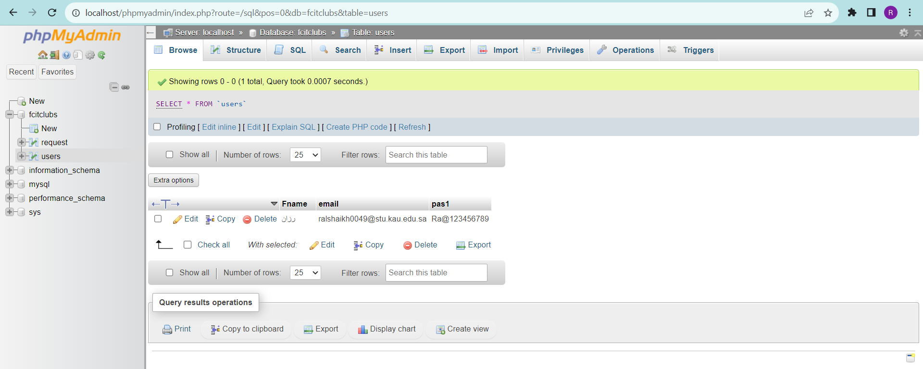

Validate the user’s email structure and the password strength from Sign up

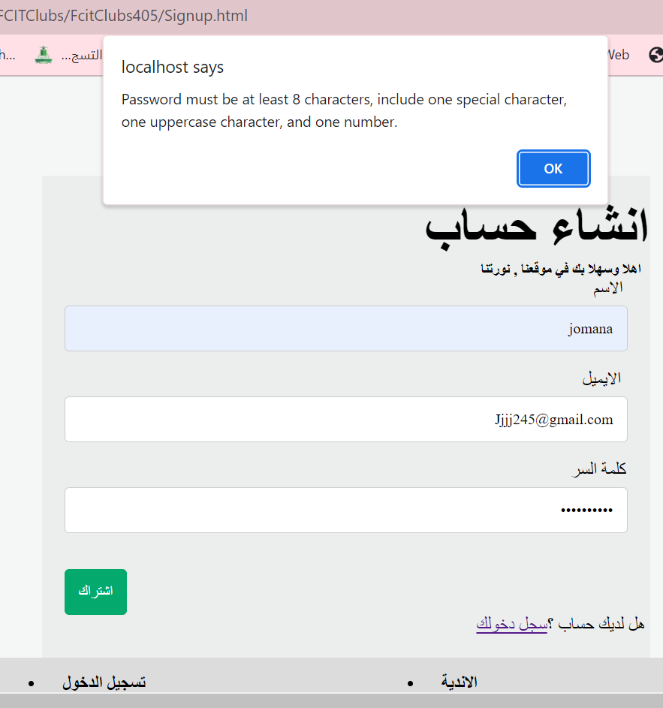

# 

# **Snippets of code**

Sign up page code

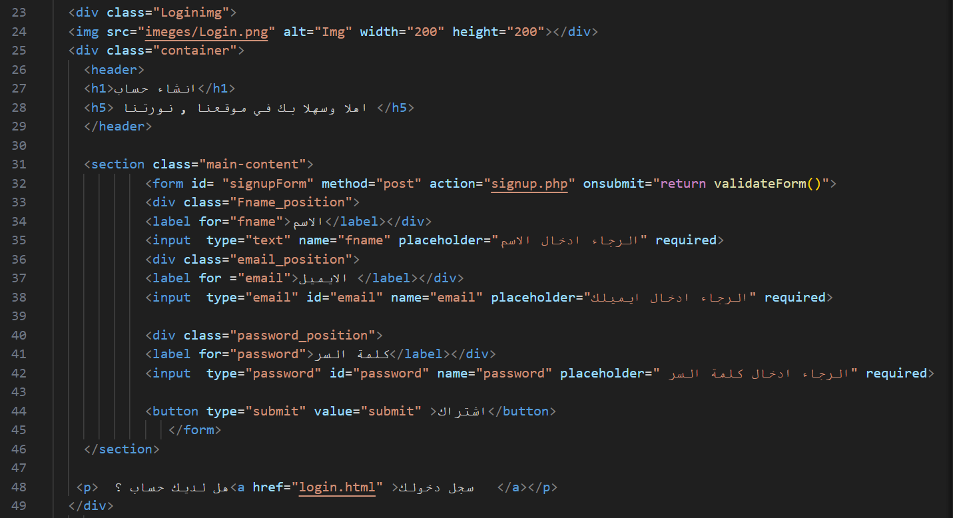

Backend page for Sign up

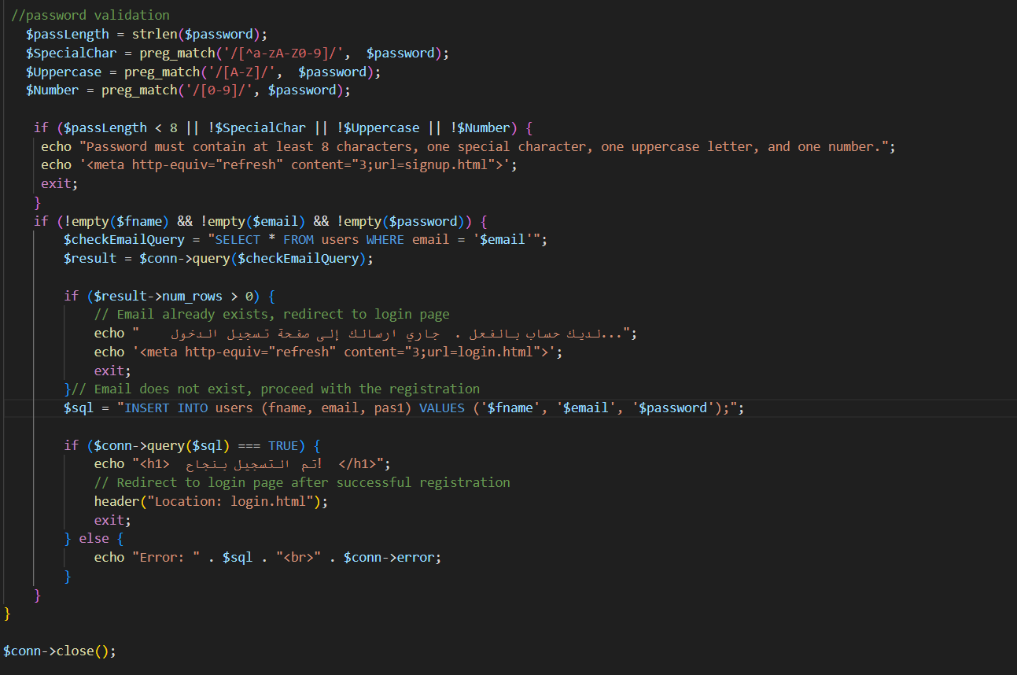

Java Script code for validate the user’s email structure and the password strength

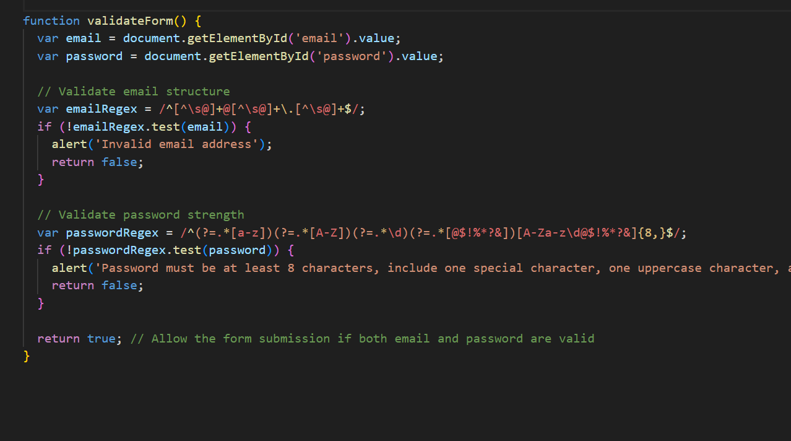

login page code

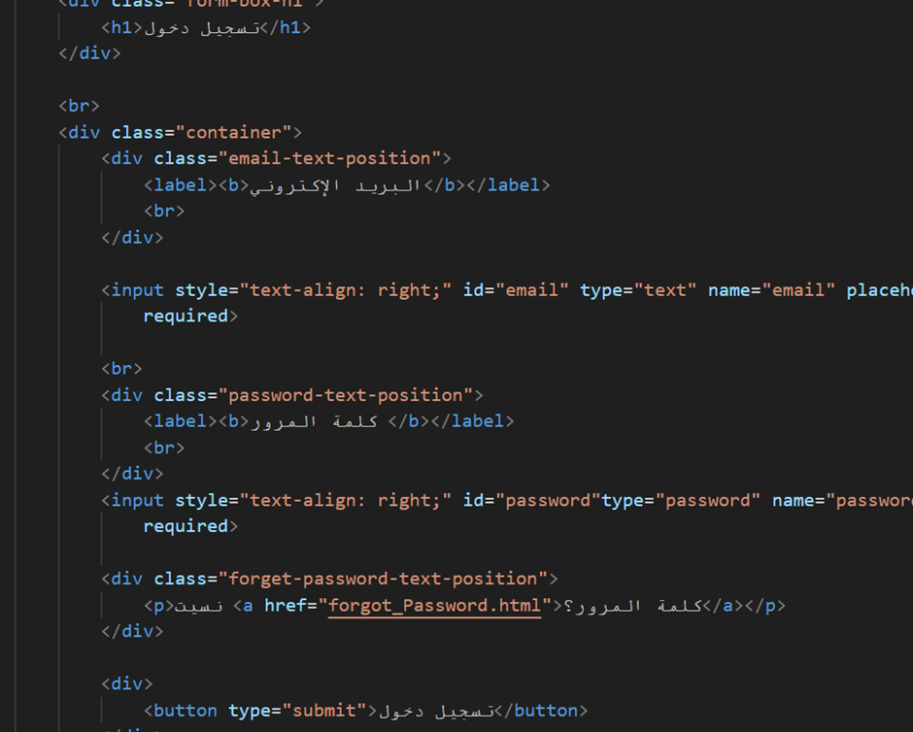

Backend for login page

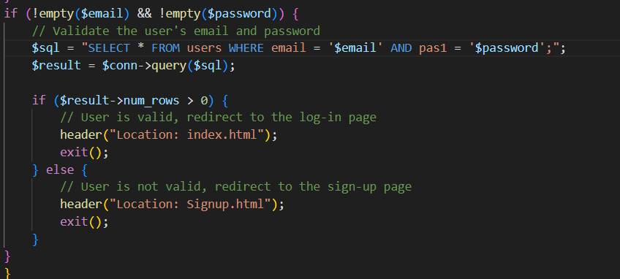

Database code for entire Project

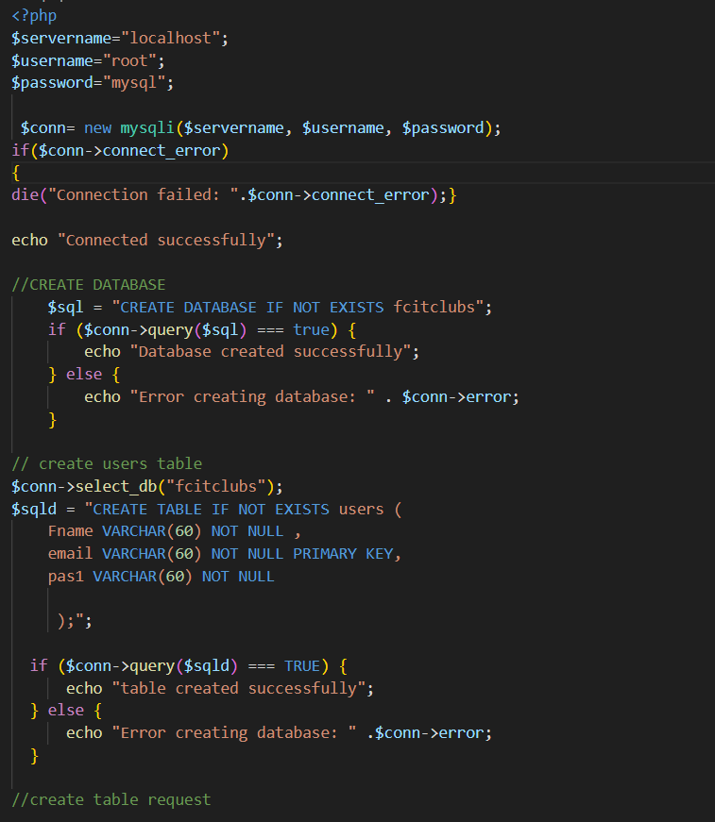

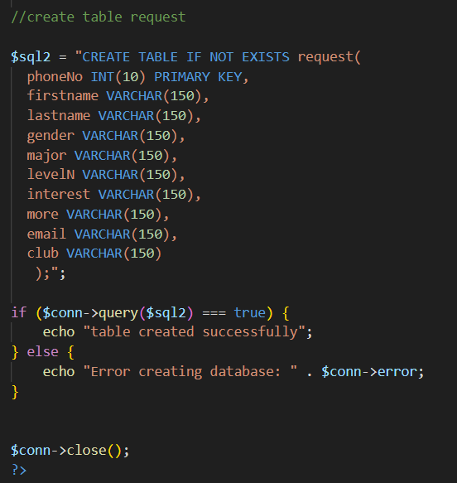

Insert Data to Database

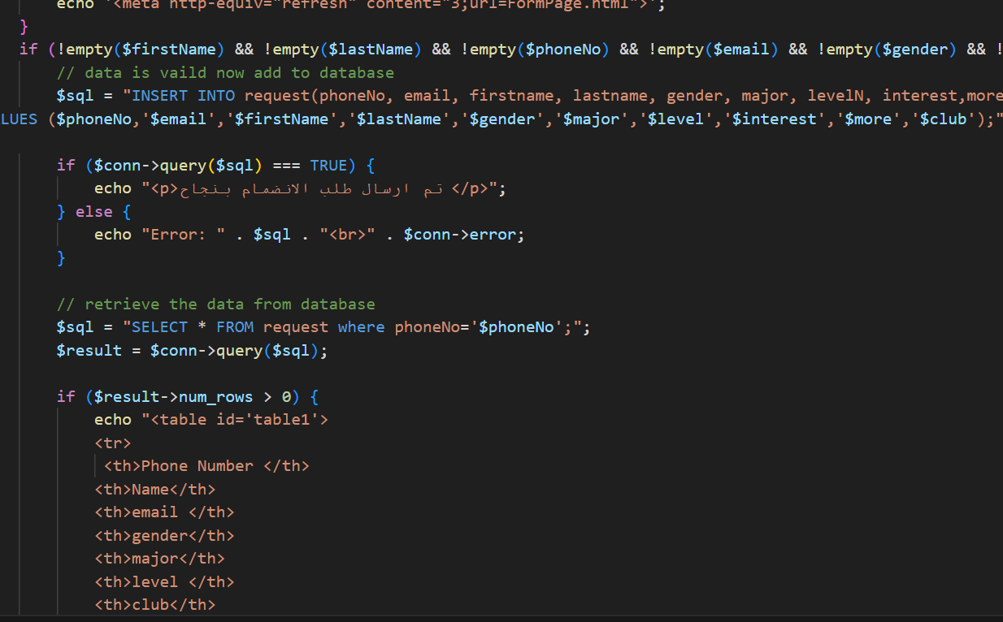

Delete processes from the database

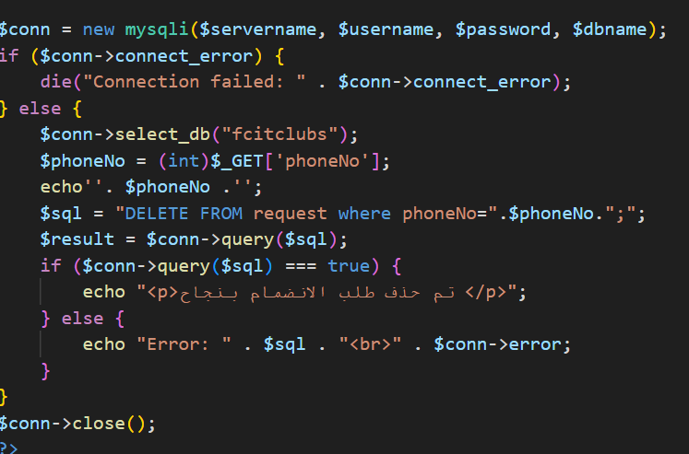

# 

# 

# 

# 

# 

# 

# 

# 

# **Conclusion**

The website makes it easier for students to find and participate in extracurricular activities, which can lead to a more varied and meaningful college experience.

Enhancing student involvement and satisfaction through the website can benefit the college as a whole. Students who participate in extracurricular activities are more likely to feel a connection to their college and its community. This could lead to higher retention rates and better academic outcomes.